|  |  |  |
| --- | --- | --- |
|  | **JSPM’s**  **RAJARSHI SHAHU COLLEGE OF ENGINEERING**  **TATHAWADE, PUNE-33**  **(An Autonomous Institute Affiliated to SavitribaiPhule Pune University,Pune)** |  |

**Department of Information Technology**

**Innovation by Faculties in Teaching Learning**

1. **Statement of Clear Goal, Use of appropriate methods, Significance of results, Effective presentation**

**Name of the Course:** Database Management System

**Name of the Faculty:** Dr. Pallavi M. Tekade

**Name of the Innovative Method used:** Youtube Video

**Name of the topic:** SQL Aggregation

**Statement of Clear Goal**:

The goal of this YouTube video is to clearly explain the concept of SQL aggregation functions such as SUM, AVG, MAX, MIN, and COUNT. The video aims to provide a hands-on understanding through examples, thereby strengthening students’ ability to analyze data using SQL queries.

**Significance of result:**

Students developed a better grasp of applying aggregate functions in real-life scenarios involving large datasets. The visual explanation helped in cementing theoretical concepts by pairing them with practical demonstrations, making it easier for students to apply these concepts during labs and exams.

**Effective Presentation (Screenshot):**

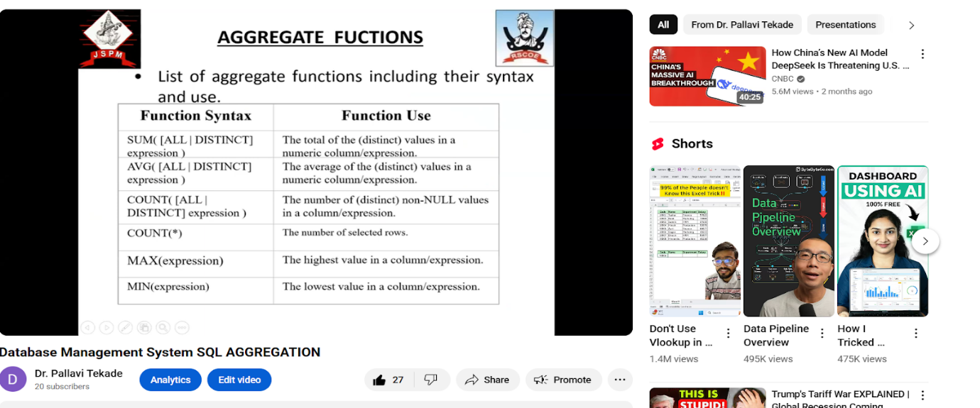

**B. Availability of work related to Innovation by Faculty in Teaching and Learning is on Institute website.**

**URL of the availability of the work on website**

<https://www.jspmrscoe.edu.in/information-technology/innovation-practices>

1. **Peer Review and Critique (Feedback):** Comments of videos.

[**https://github.com/jspmIt/PMT**](https://github.com/jspmIt/PMT)

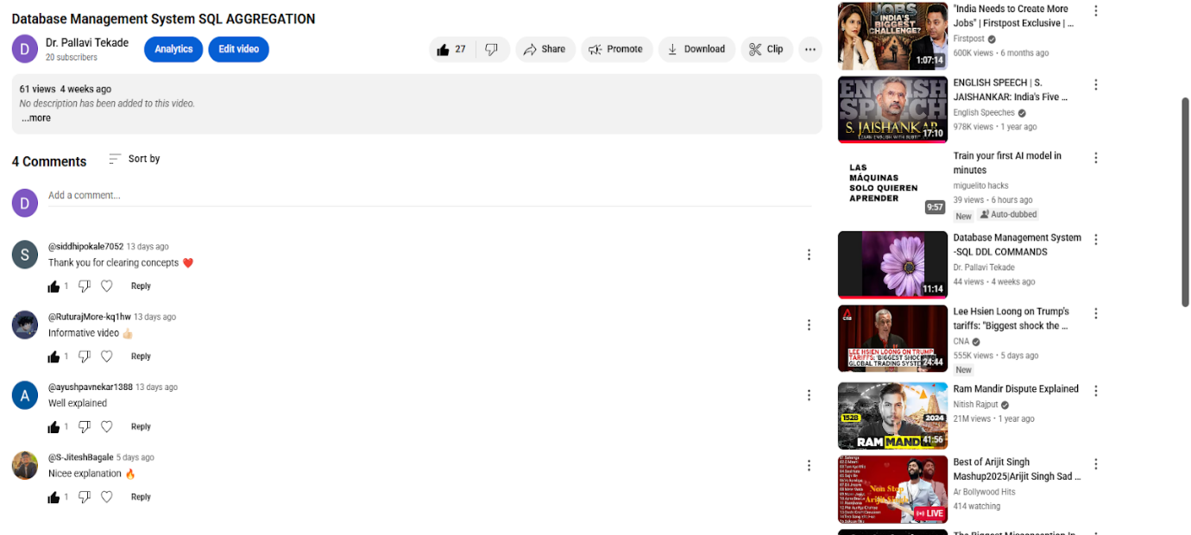

**D: Reproducibility and Reusability by other scholars for further development**

* **Views**, **likes**, **comments**, and **shares: The users watch the videos and do comments aas weel as shares with others**
* Students used it for better understanding and shares with their friends

|  |  |  |  |
| --- | --- | --- | --- |
| **Sr.No** | **Innovation Used by** | **Details of User** | **Purpose of**  **Reproducibility and Reusability** |
| **1.** | **YouTube Video** | **Dr. P. M. Tekade** | Used the content to demonstrate the practical for second and third year students |

**Course Co-ordinator Module Co-ordinator HOD**

Dr. Pallavi M. tekade Dr. Nihar M. Ranjan

|  |  |  |
| --- | --- | --- |
|  | **JSPM’s**  **RAJARSHI SHAHU COLLEGE OF ENGINEERING**  **TATHAWADE, PUNE-33**  **(An Autonomous Institute Affiliated to SavitribaiPhule Pune University,Pune)** |  |

**Department of Information Technology**

**Innovation by Faculties in Teaching Learning**

**A. Statement of Clear Goal, Use of appropriate methods, Significance of results, Effective presentation**

**Name of the Course:** Database Management System

**Name of the Faculty:** Dr. Pallavi M. Tekade

**Name of the Innovative Method used:** Youtube Video

**Name of the topic:** SQL DML Commands

**Statement of Clear Goal**:

To impart a strong conceptual understanding of SQL Data Manipulation Language (DML) commands such as INSERT, UPDATE, DELETE, and SELECT, through a structured video explanation aimed at beginners and intermediate learners.

**Significance of result:**

The video enhanced student engagement and comprehension of DML operations. It bridged the gap between syntax and real-world database interactions by demonstrating how data can be effectively managed and modified in relational databases.

**Effective Presentation (Screenshot):**

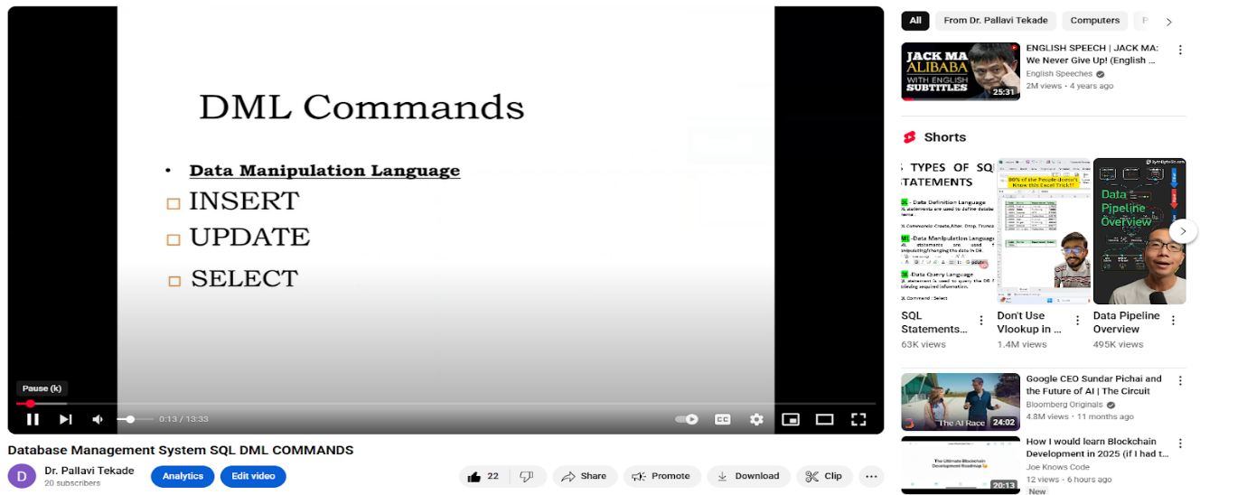

**B. Availability of work related to Innovation by Faculty in Teaching and Learning is on Institute website.**

**URL of the availability of the work on website**

<https://www.jspmrscoe.edu.in/information-technology/innovation-practices>

1. **Peer Review and Critique (Feedback):** Comments of videos.

**Work is available for peer review and critique on github.**

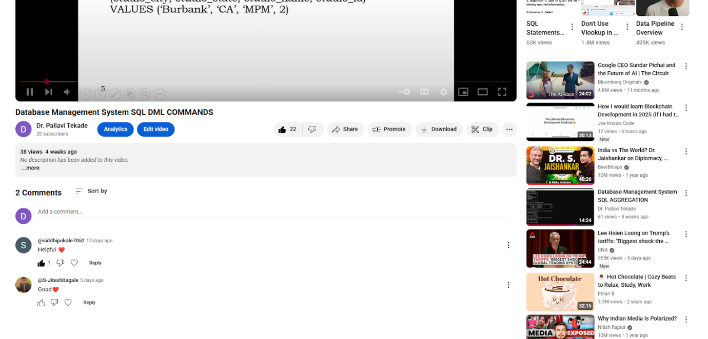

**D: Reproducibility and Reusability by other scholars for further development**

* **Views**, **likes**, **comments**, and **shares: The users watch the videos and do comments aas weel as shares with others**
* Students used it for better understanding and shares with their friends

|  |  |  |  |
| --- | --- | --- | --- |
| **Sr.No** | **Innovation Used by** | **Details of User** | **Purpose of**  **Reproducibility and Reusability** |
| **1.** | **YouTube Video** | **Dr. P. M. Tekade** | Used the content to demonstrate the practical for second and third year students |

**Course Co-ordinator Module Co-ordinator HOD**

Dr. Pallavi M. tekade Dr. Nihar M. Ranjan

|  |  |  |
| --- | --- | --- |
|  | **JSPM’s**  **RAJARSHI SHAHU COLLEGE OF ENGINEERING**  **TATHAWADE, PUNE-33**  **(An Autonomous Institute Affiliated to SavitribaiPhule Pune University,Pune)** |  |

**Department of Information Technology**

**Innovation by Faculties in Teaching Learning**

**A. Statement of Clear Goal, Use of appropriate methods, Significance of results, Effective presentation**

**Name of the Course:** Database Management System

**Name of the Faculty:** Dr. Pallavi M. Tekade

**Name of the Innovative Method used:** Youtube Video

**Name of the topic:** SQL DDL COMMANDS

**Statement of Clear Goal**:

To provide students with a foundational understanding of SQL DDL (Data Definition Language) commands such as CREATE, ALTER, and DROP, through clear video demonstrations that support anytime learning.

**Significance of result:**

The video helped students grasp how to define and modify database structures using DDL commands. After watching, students displayed improved confidence in designing database schemas and working with table structures. This resulted in more effective participation in database design exercises.

**Effective Presentation (Screenshot):**

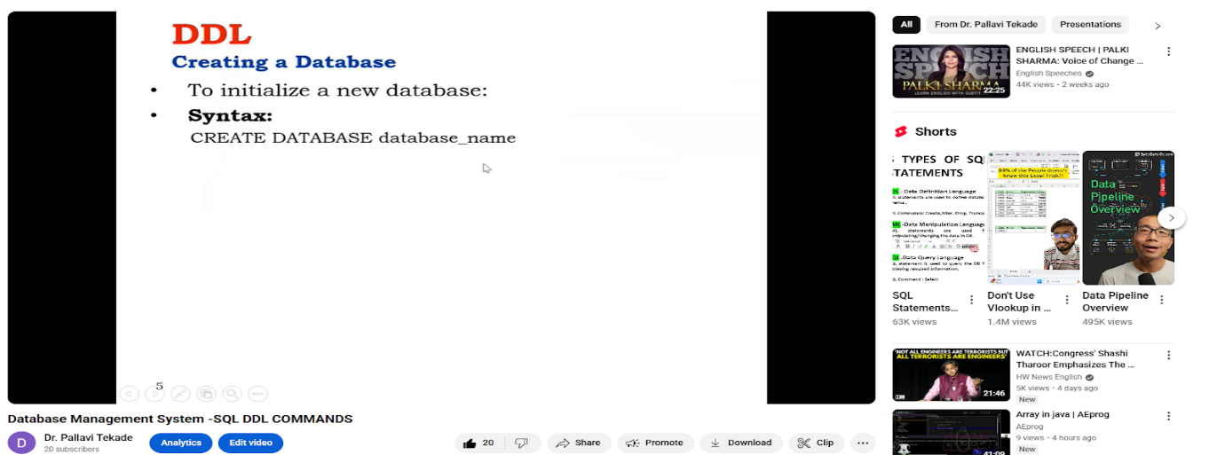

**B. Availability of work related to Innovation by Faculty in Teaching and Learning is on Institute website.**

**URL of the availability of the work on website**

<https://www.jspmrscoe.edu.in/information-technology/innovation-practices>

**C.Peer Review and Critique (Feedback):** Comments of videos.

**Work is available for peer review and critique on github.**

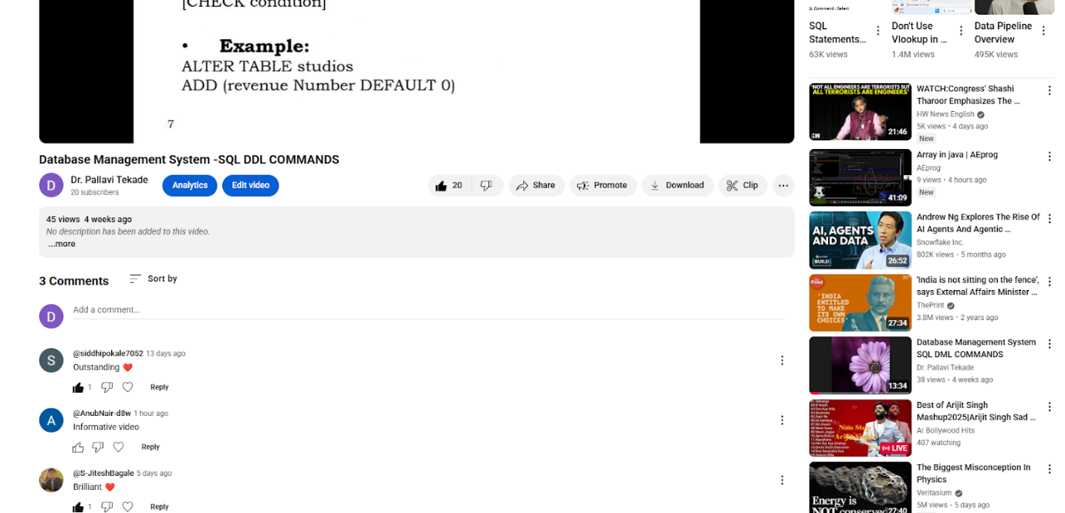

**D: Reproducibility and Reusability by other scholars for further development**

* **Views**, **likes**, **comments**, and **shares: The users watch the videos and do comments aas weel as shares with others**
* Students used it for better understanding and shares with their friends

|  |  |  |  |
| --- | --- | --- | --- |
| **Sr.No** | **Innovation Used by** | **Details of User** | **Purpose of**  **Reproducibility and Reusability** |
| **1.** | **YouTube Video** | **Dr. P. M. Tekade** | Used the content to demonstrate the practical for second and third year students |

**Course Co-ordinator Module Co-ordinator HOD**

Dr. Pallavi M. tekade Dr. Nihar M. Ranjan